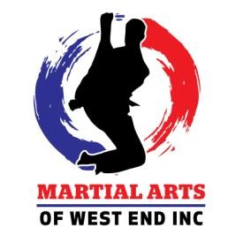

Black Belt Oath

I commit to the pursuit of Black Belt Excellence in every area of my life.
I will develop the wisdom to recognize what is right, and the courage to act upon it.

I will discipline my mind and body to remain patient, focused, and positive in the face of adversity.

I will walk with humility in my achievements, and show respect, appreciation, and loyalty to both my seniors and those I lead.

I will pursue continuous growth physically, mentally, emotionally, and spiritually striving each day to become a living example of the principles of martial arts.

I will lead by example.
I will protect the standard.
I will be better every day.

________________________________________________
Signature

_________________________
Date

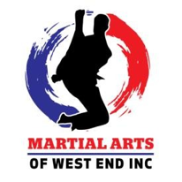
Black Belt Testing Approval Form
Be Better Every Day

Student Information
Student Name: ___________________________Current Rank: ______________________

Date of Evaluation: _____________________________

Eligibility Verification
To be considered for Black Belt Testing, all candidates must meet MAWE standards of readiness, consistency, and character.

Instructor Initial Each Requirement:
☐ Attendance Requirement Met
(Consistent training; minimum standard maintained)
☐ Curriculum Proficiency Demonstrated
(Forms, techniques, combinations, and application)
☐ Tip Requirements Completed
(All required tips earned for current rank)
☐ Sparring & Application Readiness
(Control, timing, composure, and partner safety)
☐ Physical Conditioning Standard Met
(Endurance, strength, and technical execution)
☐ Black Belt Attitude & Character
(Respect, humility, leadership, and perseverance)

Instructor Evaluation Notes
(Provide specific feedback on readiness, strengths, and areas of focus)
____________________________________________________________________________________________________________________________________________________________________________________________________________________________________________________________________________________________________________________________________________
Approval Status

☐ APPROVED for Black Belt Testing
☐ NOT YET APPROVED — Continue Development

If Not Yet Approved — Required Focus Areas
________________________________________________________________________________________________________________________________________________________________________________________________________________________________________________________________________________________________________________________________________________________________________________________________________

Signatures

Instructor Name: _______________________________Date: _________________

Signature: ________________________________

_____________________________________________________________________________
Master / Chief Instructor Authorization
All Black Belt Candidates must receive final approval from the Master / Head Instructor prior to testing.

☐ APPROVED
☐ NOT APPROVED AT THIS TIME

Master / Head Instructor Name: _____________________________Date: ________________

Signature: ________________________________

_____________________________________________________________________________

MAWE Standard
Black Belt is not a participation award — it is a demonstration of readiness, leadership, and personal transformation.
Approval signifies that the student represents the standards, discipline, and spirit of Martial Arts of West End.
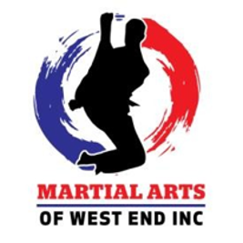
STUDENT BIOGRAPHY
(This will be used to speak about you during the Black Belt Tea Ceremony)

Please complete this form thoughtfully.
Your responses will become part of your martial arts record and help document your personal journey and growth.

Personal Information
Name: ________________________________ Current Belt Rank: ________________________________
Date Training Began: ____________________ Occupation / School: ______________________________

Martial Arts Accomplishments
Please list any significant achievements, awards, certifications, leadership positions, tournament accomplishments, or other recognitions you have earned through martial arts.
______________________________________________________________________________________________________________________________________________________________________________________________________________________________________________________________________________

Personal Growth
How has your life improved since you began training at MAWE?
Consider areas such as confidence, discipline, leadership, respect, physical fitness, perseverance, relationships, or other personal growth.
______________________________________________________________________________________________________________________________________________________________________________________________________________________________________________________________________________

Martial Arts Goals
What are your current goals in martial arts, and how do you plan to achieve them?
Include both your short-term and long-term goals, as well as how you hope to continue growing as a martial artist and leader.
______________________________________________________________________________________________________________________________________________________________________________________________________________________________________________________________________________

